**EXPERIMENT 9**

**Aim:** To configure IP address between two networks by using 2 Routers, 2 Switches and number of PCs.

**Equipment:** Cisco Packet Tracer software

**Theory:**

The network layer is responsible for the delivery of individual packets from the source to the destination host. The packet transmitted by the sending computer may pass through several LANs or WANs before reaching the destination computer. For this level of communication, we need a global addressing scheme; which we call IP Address.

A Router is a three-layer device which routes packets based on their logical addresses. A router normally connects LANs and WANs in the internet and has a routing table used for making decisions about the route.

**Procedure:** The following steps can be used to configure the IP address in three networks by Using PCs and Router:

**Step 1:** Select Number of PCs from Generic and Devices.

**Step 2:** Make Connections between PCs and Switches through straight copper wire.

**Step 3:** Connect Switches and routers through straight copper wire, selecting 0/0 port of routers.

**Step 4:** Connect both Routers using copper cross wire and selecting 0/1 ports.

**Step 5:** Configure each PC with Unique IP Address using same class for the PCs in same network.

**Step 6:** Configure each PC with Gateway Address of same class for same network.

**Step 7:** Configure the Routers at 0/0 ports by entering the same IP Address (Default Gateway of networks) of each PC and tick the ON option on the Port Status.

**Step 8:** Configure the routers at 1/0 ports by entering unique IP Address of same class other than class used for PCs and tick the ON option on the Port Status.

**Step 9:** Add simple PDU from Source PC to Destination PC.

**Step 10:** Click on the Simulation Mode Button which is on the right Bottom, and then simulate the Topology by clicking the Auto Capture/Play Button.

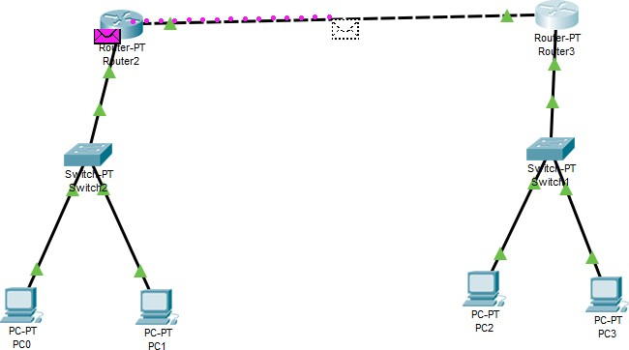

Sharing of a packet between two networks using 2 routers